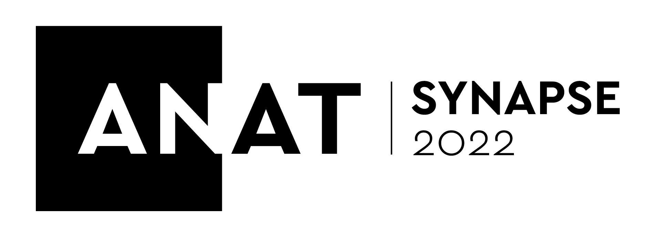

ANAT SYNAPSE RESIDENCY PROGRAM - GUIDELINES & APPLICATION FORM

GUIDELINES

ANAT is a national network that creates opportunities for experimental artists to collaborate with science and technology partners. We do this because we believe artists are essential to how we imagine and shape our future.

ANAT is calling for applications from artists and scientists for our prestigious Synapse Residency program, which, since 2004, has enabled research collaborations between more than 100 artists and scientists.

ANAT Synapse involves Australian research organisations hosting artists in residence, leading to profound artistic and professional development for the participants, while also building a sustainable support base for interdisciplinary creative collaboration in Australia.

ANAT Synapse brings artists and researchers together in partnerships that generate new knowledge, ideas and processes beneficial to both fields. A distinguishing feature of the residencies is their creative research focus, with applicants dissuaded from anticipating specific outcomes at the outset.

Residencies take place over 16 weeks full-time, the equivalent part-time, or, in discrete blocks over a longer duration during 2022*. ANAT will pay participating artists a fee of $4,400 per month (or part-time equivalent) and contribute towards project material costs, accommodation expenses and return travel to the destination of the residency if required^. The host organisation will provide in-kind access to staff, equipment, space and resources, and will assist with disseminating outcomes at the conclusion of the residency~.

Benefits of undertaking an ANAT Synapse Residency
Artist:
The benefits and professional development opportunities for ANAT Synapse recipients include:
- Time to explore and develop concepts at the very inception of idea/s
- Meaningful engagement and collaboration with experts in a research field particularly relevant to the artist’s practice, contributing to rigorous artistic process
- Access to the host orgnaisation’s equipment, resources and other experienced staff~
- Focused promotion by storytelling via ANAT’s national and international network, including publicity opportunities, social media posts and stories and a dedicated creative research blog, which serves as a live document of the residency and will be archived and accessible/shareable for years to come.
- Become an ANAT Alumnus, a network of over a hundred artists, scientists and technologists. A lifelong community of remarkable, diverse and engaged professionals.
Host:
- Meaningful engagement and collaboration with an artist whose area of research is particularly relevant to the host organisation’s focus, contributing to rigorous exploration. Former hosts often report that the experience has led to profound insight, sparking unexpected areas of enquiry for them, as artists methods and approach are open and investigation lines limitless.
- Promotional opportunities shared to ANAT’s national and international network, including publicity, social media posts and stories. The artist will contribute to a dedicated creative research blog, which serves as a live document of the residency and will be archived and accessible/shareable for years to come.
- Become an ANAT Alumnus, a network of over a hundred artists, scientists and technologists. A lifelong community of remarkable, diverse and engaged professionals.

Who can apply?
Residencies are open to Australian artists (Australian citizens or permanent residents) working in any discipline and/or medium. The program is suited to artists with a self-disciplined and focused creative working process as investigations alongside the research partner will be largely self-guided. Applications indicating a clear research basis will be looked upon favourably, as this will ensure time is spent in fruitful exchanges from the onset.

To ensure a good fit between the artist and host organisation, a joint application must be submitted. It is the responsibility of the applicants to establish contact and to identify the nature of the proposed research collaboration prior to application.

Tertiary students, including PhD candidates, are ineligible to apply if the proposed residency in any way contributes to the achievement of an academic qualification. Please contact us if you are unsure about this requirement.

Residencies may also be approached as a platform for testing and informing a longer-term research project suitable for submission to the ARC Synapse Linkage program.

As an inclusive arts organisation, ANAT enables artistic perspectives that reflect contemporary Australia. We especially encourage First Nations people and those from culturally diverse backgrounds to apply.

Through our programs, we seek to reduce barriers by actively working toward accessibility best practice.

~ As agreed through prior negotiation directly with the host organisation
* Due to Covid-19 please remain flexible in your planning.
^ up to an amount of $3,500

Deliverables expected of the successful applicant:
- ANAT will share the process of the recipient’s creative research residency to our network. Our preference is for the artist to regularly contribute to a blog (initiated and hosted by ANAT and linked to our website). Contributions can consist of concepts, imagery, writing, video, notes or any other format that can be shared with our network. The ANAT Synapse blog has great professional development value, as cited by Synapse alumni, by providing storytelling and promotional opportunities for the artist and will be archived, thus can be shared or referred to for years to come.
- At the conclusion of the residency, ANAT will assist the artist to arrange a casual, in-conversation style artist talk that will be recorded and shared online.

HOW TO APPLY
Please read the guidelines on pages 1 through to 3 carefully before completing the application form.
The program is highly competitive and it is strongly recommended that you discuss your project proposal with us prior to application. To do so, please refer to the ‘Contact’ section below.

Application submission:
- Complete the form and submit by 5pm ACDT, Wednesday 16 February 2022.
- Email your application directly to: apply@anat.org.au
Please do NOT submit your application to a staff member address.

Selection Criteria:
- Originality and innovation of the proposed project;
- Artist/s professional track-record and their familiarity with the proposed area of enquiry;
- Demonstrated willingness by all parties to work collaboratively;
- Anticipated benefits to both the artist and the host organisation;
- Viability of the project in relation to the scope of the residency budget and the project’s achievability

KEY DATES
Deadline for applications: 5pm (ACDT), Wednesday 16 February 2022
Notification of outcome: March 2022
Residency period: Between April and December, 2022

CONTACT
Artists are encouraged to contact ANAT directly with any questions:

Melissa DeLaney
ANAT CEO
(08) 8231 9037
melissa@anat.org.au

NB: please do NOT submit your application to a staff member email address. See ‘How to Apply’ for the correct email address.

See next page for application form.

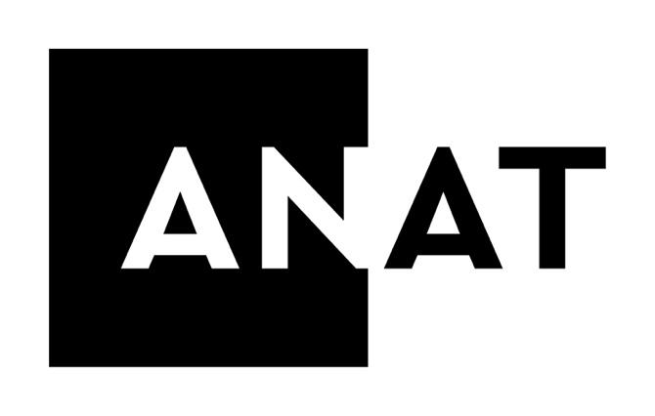

ANAT is assisted by the Australian Government through the Australia Council for the Arts, the South Australian Government through Arts SA and through the Visual Arts and Craft Strategy, an initiative of Federal and State Governments. The ANAT Synapse Residency program is supported by the Copyright Agency’s Cultural Fund, which supports Australia’s writers, artists, publishers and arts organisations.

APPLICATION FORM - ANAT SYNAPSE RESIDENCY PROGRAM 2022

- PROJECT PARTICIPANTS
Please provide artist(s) information in the table below. All fields marked with an asterisk* are compulsory.

ARTIST | If more than one artist is applying please duplicate the table below and complete it for each artist.
*Name:
*Street:
*Suburb:
*State & Postcode:
*Phone:
*Email:
URL:
ABN (if held):
*Registered for GST? | Yes / No (please circle/highlight one)
*Signed:

Please provide the Host information in the table below. All fields marked with an asterisk* are compulsory.
HOST ORGANISATION | If more than one host organisation is applying please duplicate the table below and complete it for each host.
*Organisation:
*Contact person:
*Street:
*Suburb:
*State & Postcode:
*Phone:
*Email:
*URL:
*Signed:

- PROJECT PROPOSAL
Please complete all fields below

Project Title* (please provide a title for your creative research project)
(up to 40 words)
Description of the proposed project* (up to 500 words)
How does each project partner expect to benefit from the residency?*
(up to 250 words)
Description of artist’s practice and previous collaboration/s with science partners (if any) *
(up to 250 words)
Description of the host organisation and previous experience working with artists (if any).*
(up to 250 words)
Proposed Residency Dates*
If you are unsure of exact dates, please provide us with an estimate.

- BUDGET
A ONE-PAGE project budget must be supplied with your application. A template is provided below.

INCOME
Cash:
Total of Synapse Residency grant | $
In-kind:
HOST ORGANISATION  - Venue resources  - Staff resources  - Public liability insurance (if able to incl. in organisation policy) | $  $  $
ARTIST:  - Artist’s equipment (e.g. computing, camera, video)  - Other: project materials, etc  - Public liability insurance (if host not able to incl. in their policy) | $  $  $
ANAT:  - Staff resources  - Blog set-up & maintenance  - Marketing, publicity and social media | $ 25,000  $ 500  $ 2,000
Total In-kind: | $
TOTAL INCOME | $
EXPENDITURE
Cash:
ARTIST:  - Artist fees ($4,400/month)  - Project materials, travel costs etc | $ 17,600  $
Total Cash (Synapse residency grant total) | $
In-kind:
HOST ORGANISATION  - Venue resources  - Staff resources  - Public liability insurance (if able to incl. in organisation policy) | $  $  $
ARTIST:  - Artist’s equipment (e.g. computing, camera, video)  - Other: project materials, etc  - Public liability insurance (if host not able to incl. in their policy) | $  $  $
ANAT:  - Staff resources  - Blog set-up & maintenance  - Marketing, publicity and social media | $ 25,000  $ 500  $ 2,000
Total In-kind: | $
TOTAL EXPENDITURE | $

- SUPPORT MATERIAL
Please provide NO MORE THAN TWO of the following. Select those that best demonstrates your artistic practice:
- Four images (attachments, up to 1mb each OR URLs)
- Four minutes of video (URL only)
- Four minutes of audio (URL only)
- One interactive work (URL only)
- Four webpages (direct URLs only)

Please attach your support material to your application email AND/OR list your support material URLs in the table provided below.

Support Material URLS:

Support Material Type (image, audio etc.) | URL

- SUMMARY BIOGRAPHIES OR CV’S
Please attach two summary biographies or CV’s: one for the artist(s) and one for the collaborating scientist(s)/researcher(s) from the host organisation. Maximum TWO PAGES for each CV/biography.

- ARTIST CONFIRMATION*
Please tick the statements below to acknowledge the project requirements of the Synapse application process. If you are unable to confirm these then your application is unable to be considered.
If needed, please refer to the guidelines at pages 1 to 3 for further information.

I have engaged with the Host Organisation and discussed the proposed residency project in full. The Host Organisation has confirmed they will host me as resident artist if my application is successful.
I declare that the proposed project does NOT contribute to the achievement of an academic qualification in any way.

APPLICATION CHECKLIST
__ I have completed questions 1 to 5 above
__ I have attached the support material
__ I have attached a budget
__ I have attached my artist biography or CV
__ I have attached the Researcher's biography or CV
__ I have read and checked the two boxes at item 6 above

DEMOGRAPHIC QUESTIONNAIRE (non-compulsory)
ANAT and its partners value your interest in this program. It's important to us to understand more about you. Please feel free to contribute this confidential information.

How do you identify? (please bold your answer)
Woman
Man
Non-binary
Prefer to self-describe, below (written response)
Prefer not to answer

Age range: (please bold your answer)
13 - 25
26 - 35
36 - 64
65 - 71
72 - 80
81 and over
Prefer not to answer
Do you identify as Aboriginal and/or Torres Strait Islander? (please bold your answer)
Yes
No
Prefer not to answer

Do you identify as culturally and linguistically diverse (CALD)? (please bold your answer)
Yes
No
Prefer not to answer

Do you identify as LGBTQIA+? (please bold your answer)
Yes
No
Prefer not to answer

Accessibility awareness:
Are you a person living with a disability? (please bold your answer)
Yes
No
Prefer not to answer
If yes, please tell us how we may assist you with access and inclusion requirements:

_______________________________________________________________________

Location: Residential State or Territory: (please bold your answer)

ACT NSW NT Qld SA Vic Tas WA Based overseas

Region you are based: (please bold your answer)

Metropolitan Regional Remote International

